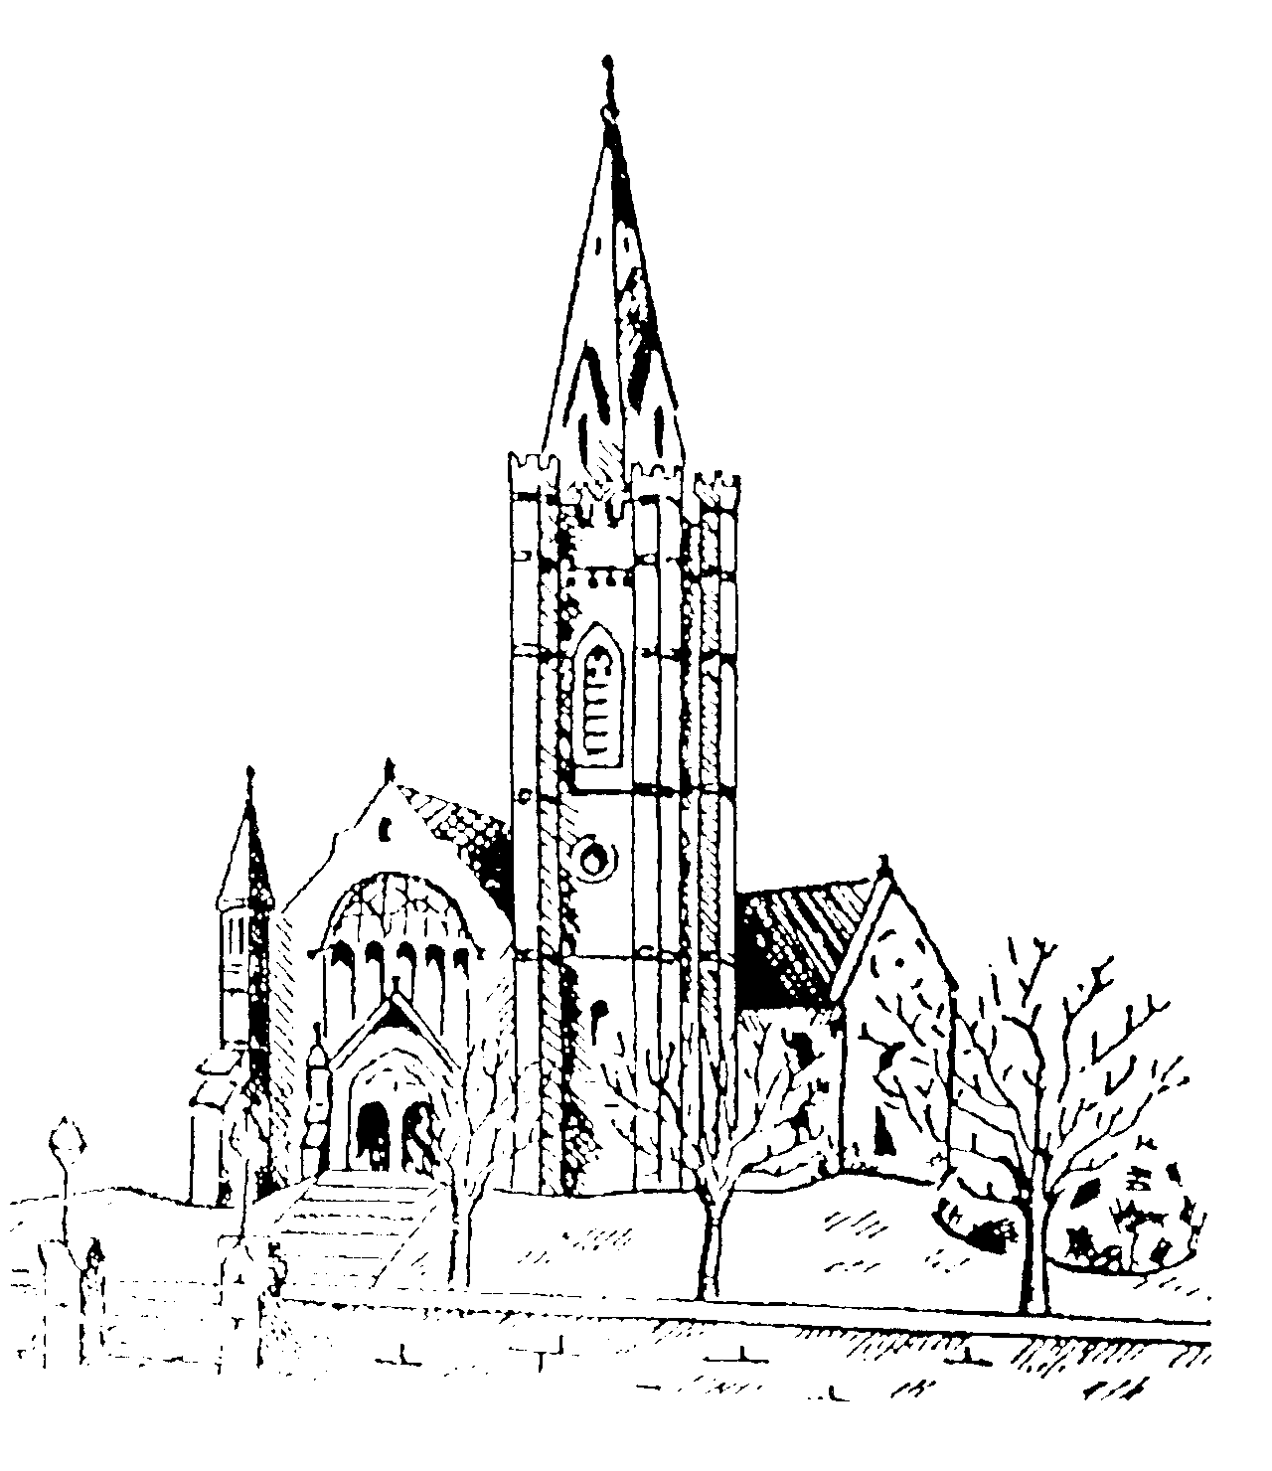
WINDSOR PRESBYTERIAN CHURCH
Derryvolgie Avenue, Belfast BT9 6FL

Minister: Rev. Ivan Steen

19th March 2020

Dear Windsor Family,

We find ourselves facing a very difficult moment in history with local and international measures in place to tackle the threat of Covid-19. These measuresSo, what do you think? With God on our side like this, how can we lose? If God didn’t hesitate to put everything on the line for us, embracing our condition and exposing himself to the worst by sending his own Son, is there anything else he wouldn’t gladly and freely do for us? And who would dare tangle with God by messing with one of God’s chosen? Who would dare even to point a finger? The One who died for us—who was raised to life for us!—is in the presence of God at this very moment sticking up for us. Do you think anyone is going to be able to drive a wedge between us and Christ’s love for us? There is no way! Not trouble, not hard times, not hatred, not hunger, not homelessness, not bullying threats, not backstabbing, not even the worst sins listed in Scripture: have now come into the church with us called upon to play our part. Following a leadership meeting last night all normal activities have been suspended and this includes our Sunday gathering.
It is frustrating that at a time, when proximity is desired we must keep our distance. That said we must now be creative in reaching out to each other with messages and practical help as appropriate. Many of you have already been making and delivering packages of food and products to those who are limited and the swell of kindness from the Christian family has been wonderful to see.

At Windsor we have a lot of people who have been through difficult times either from displacement from country and family or recent medical issues this virus threat is particularly frightening and care for them a pressing necessity. In addition we have a number of medical staff who will be facing this virus head on! Your prayers and support of these guys is appreciated.
We will be setting up on line opportunities to gather with a Facebook live broadcast set for this coming Sunday at 11.00am. Face book messenger or email will be monitored regularly and please keep in contact.

This little passage from Romans 8 has been on my mind(Message version)
So, what do you think? With God on our side like this, how can we lose? If God didn’t hesitate to put everything on the line for us, embracing our condition and exposing himself to the worst by sending his own Son, is there anything else he wouldn’t gladly and freely do for us? And who would dare tangle with God by messing with one of God’s chosen? Who would dare even to point a finger? The One who died for us—who was raised to life for us!—is in the presence of God at this very moment sticking up for us. Do you think anyone is going to be able to drive a wedge between us and Christ’s love for us? There is no way! Not trouble, not hard times, not hatred, not hunger, not homelessness, not bullying threats, not backstabbing, not even the worst sins listed in Scripture:

Please keep in touch with each other, with your neighbours, friends and colleagues and know we are working for our community and that ministerial support is available to all.

Yours faithfully,
Ivan

