Will you take part in Windsor Presbyterian’s ‘Home Run for Habitat’?

Windsor are once again partnering with Habitat for Humanity NI to build homes, community and hope.

We are asking our members & friends of Windsor Presbyterian Church to take part in a 6K sponsored run to raise funds for Habitat for Humanity’s COVID-19 response. Whilst the pandemic has impacted almost everyone on the planet, Jesus calls us to look to those most vulnerable. 1.8 billion people are living in conditions of absolute poverty without access to a safe place to live, clean water or basic sanitation. We chose a 6K run because 6K is the average distance people in the developing world walk for water.

The run will be completed by individuals or small groups during the last week of August (24th to 30th). The 6K route will take place in and around the Windsor Parish, passing some familiar landmarks. You can choose to walk or complete the 6K over 6 days! This is something we can do together, whether as a runner or supporter, to raise as much as we can.

Habitat have been delivering emergency hygiene kits in India, building an emergency medical centre in Romania and improving access to clean water in Zambia by sinking a solar powered borehole. Read more at https://www.habitatni.co.uk/donate/covid19/habitatscovidresponse

If you would like to run, walk or make a donation, contact Heather Hanna by e-mail (heather.hanna@btinternet.com).
We will give you more information on how to take part, the 6K route and how to start fundraising.

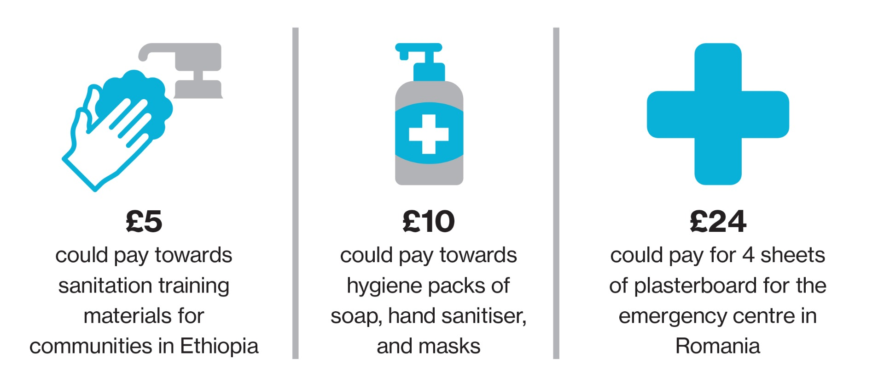

You can donate, or ask others to sponsor you, using our fundraising page at https://habitatni.enthuse.com/pf/windsorpresbyterian

